Zurich, 28.11.24

Dr. Thomas Dursch
Chief editor, Nature Chemical Engineering

Subject: Revised NATCHEMENG-24061044

Dear Dr. Dursch, dear Tom,
Thank you for your decision on the manuscript, now titled ‘Towards green acetylene synthesis and application’ by Z. Zhang, A. Nabera, G. Guillén-Gosálbez, and J. Pérez-Ramírez, and for the opportunity to submit a duly revised version to Nature Chemical Engineering. We are delighted by the positive feedback from our peers and the editorial team, and we have thoroughly addressed all the points raised during the revision.
As agreed, we have revised the manuscript format into a Perspective (with a review component) to emphasize the forward-looking vision of renewable acetylene production. Additionally, we have modified the title, clarified the objectives in the introduction, shortened Section 2, and added recent advancements in acetylene applications as well as projections for the availability of renewable feedstocks. These actions sharpen the focus on the unique aspects highlighted by Reviewers #1 and #3, while addressing the primary concern of Reviewer #2. We appreciate your exception regarding the length, which we have respected in the revision.
We remain convinced that this Perspective can inspire a shift in research efforts toward renewable building blocks for the chemical industry, particularly revitalizing the sustainable production and use of acetylene. Please find attached detailed responses to the Reviewers, along with the revised manuscript and supplementary information, both in clean form and with marked changes.
We look forward to your decision.
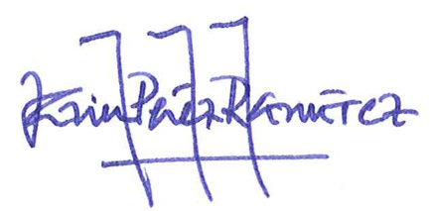
Best wishes,

Javier Pérez-Ramírez

